
Name : Bisma Fatima
Class : CS-24 A
Roll no : F24605036
Course : Database system lab
Code : CS-161
Lecturer : MISS Noushin Saba

LAB TASK WEEK 01

INLAB TASK
Task 1
• Create a new database named "StudentRecords".
Steps:
Step 1: Open Microsoft Access
Open Microsoft Access on your computer.
Step 2: Click on "Blank Database"
In the start-up screen, click on "Blank Database".
Step 3: Enter Database Name
In the "File Name" field, enter "StudentRecords".
Step 4: Choose Location
Choose a location to save your database, such as your desktop or documents folder.
Step 5: Click "Create"
Click the "Create" button to create the new database.
Your new database, "StudentRecords", is now created and ready for use.
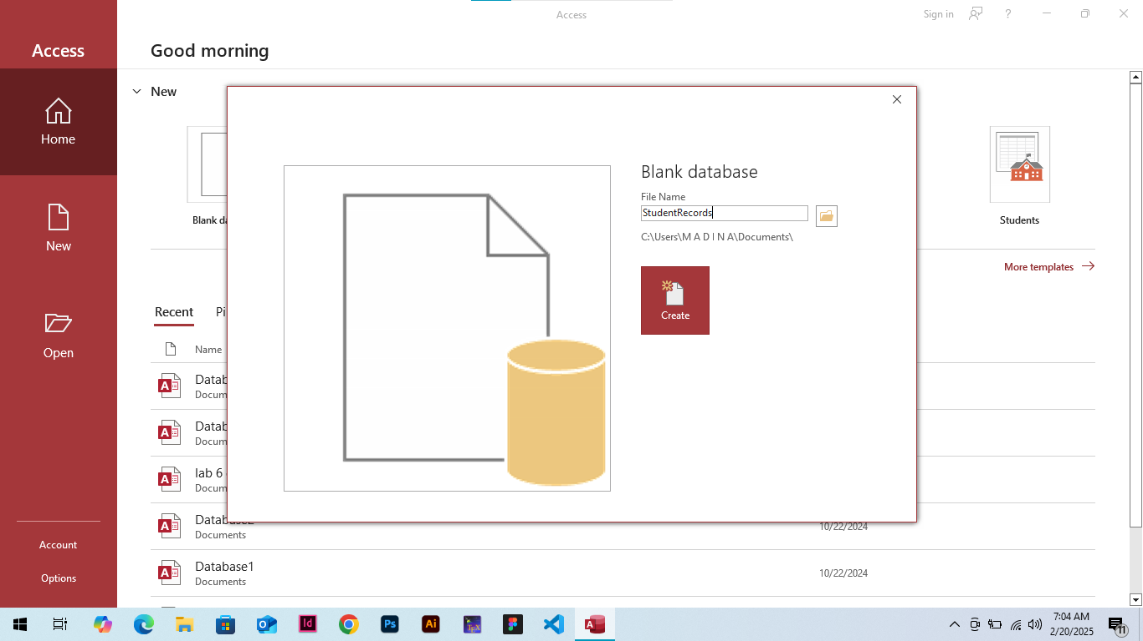
• Create a table called "Students" with the following fields:
o StudentID (Number)
o Name (Short Text)
o Age (Number)
o Email (Short Text)
o EnrollmentDate (Date/Time)
• Set "StudentID" as the Primary Key.
Steps
Step 1: Open the Database
Open the "StudentRecords" database you created earlier.
Step 2: Access Table Design
Click on the "Create" tab in the ribbon and click on "Table Design".
Step 3: Add Fields
In the "Table Design" view, add the following fields:
- StudentID (Data Type: Number)
- Name (Data Type: Short Text)
- Age (Data Type: Number)
- Email (Data Type: Short Text)
- EnrollmentDate (Data Type: Date/Time)
Step 4: Set Primary Key
Select the "StudentID" field and click on the "Primary Key" button in the ribbon.
Step 5: Save the Table
Click "Save" on the "Quick Access Toolbar" or press Ctrl+S to save the table. Name the table "Students".
The "Students" table is now created with the specified fields and "StudentID" set as the Primary Key.
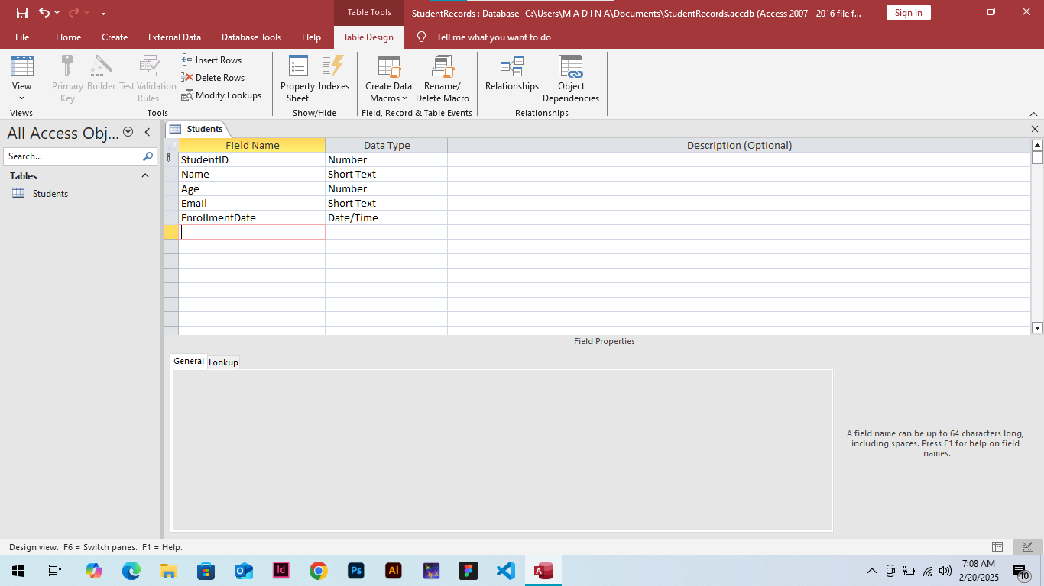
• Add at least 5 student records to the "Students" table.
Steps
Step 1: Open the "Students" Table
Open the "StudentRecords" database and click on the "Students" table in the Navigation Pane.
Step 2: Switch to Datasheet View
Click on the "View" button in the ribbon and select "Datasheet View" to switch to a spreadsheet-like view.
Step 3: Add New Records
Click on the first blank row at the bottom of the table to start adding new records.
Step 4: Enter Student Records
Enter the student records.
Step 5: Save Changes
Click on the "Save" button on the Quick Access Toolbar or press Ctrl+S to save the changes.
The 5 student records are now added to the "Students" table.

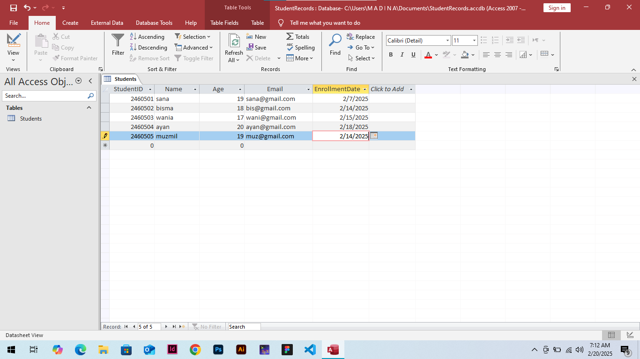

• Modify one of the records (update the email of a student).
Steps
Using the Replace Feature
Step 1. Open the "Students" table:
Open the "StudentRecords" database and click on the "Students" table in the Navigation Pane.
Step 2. Switch to Datasheet View:
Click on the "View" button in the ribbon and select "Datasheet View" to switch to a spreadsheet-like view.
Step 3. Select the record to update:
Click on the row selector (the gray box to the left of the record) to select the record for "John Doe" (StudentID 1).
Step 4. Go to the field to update:
Click on the "Email" field for John Doe's record.
Step 5. Use the Replace feature:
Press Ctrl+H or click on the "Home" tab in the ribbon, then click on the "Replace" button in the "Find" group.
Step 6. Enter replacement values:
In the "Find and Replace" dialog box, enter the old email address in the "Find what" field and the new email address in the "Replace with" field.
Step 7. Replace the value:
Click on the "Replace" button to replace the old email address with the new one.
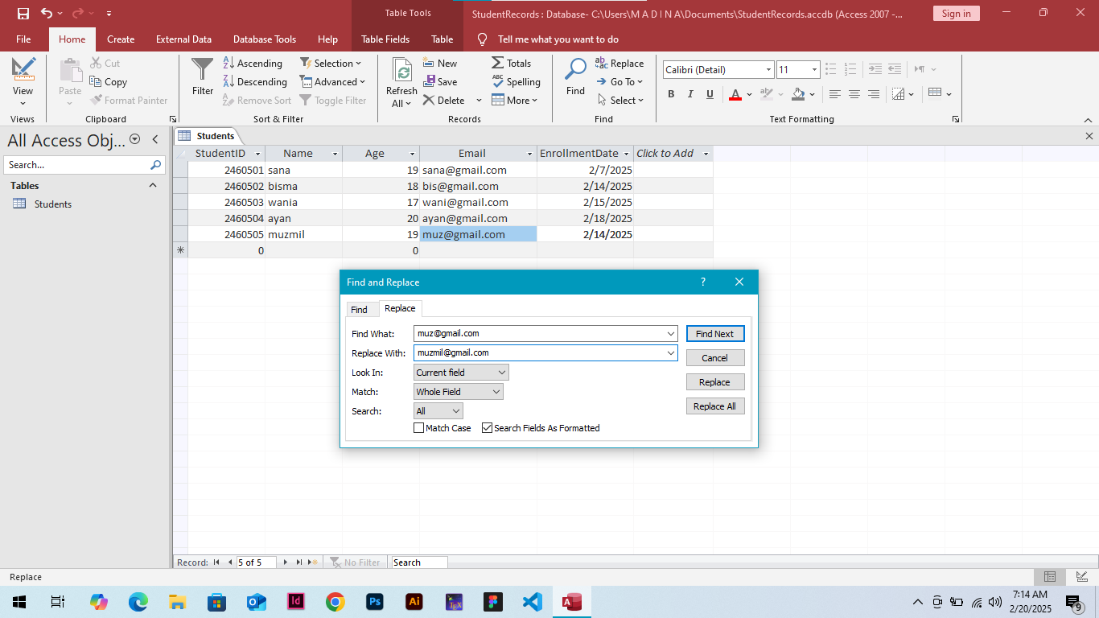

Task 2
• Create a second table named "Courses" with the fields:
o CourseID (Number, Primary Key)
o CourseName (Short Text)
o Credits (Number)
steps:
Step 1: Open the Database
Open the "StudentRecords" database.
Step 2: Access Table Design
Click on the "Create" tab in the ribbon and click on "Table Design".
Step 3: Add Fields
In the "Table Design" view, add the following fields:
- CourseID (Data Type: Number)
- CourseName (Data Type: Short Text)
- Credits (Data Type: Number)
Step 4: Set Primary Key
Select the "CourseID" field and click on the "Primary Key" button in the ribbon.
Step 5: Save the Table
Click "Save" on the "Quick Access Toolbar" or press Ctrl+S to save the table. Name the table "Courses".
The "Courses" table is now created with the specified fields and "CourseID" set as the Primary Key.

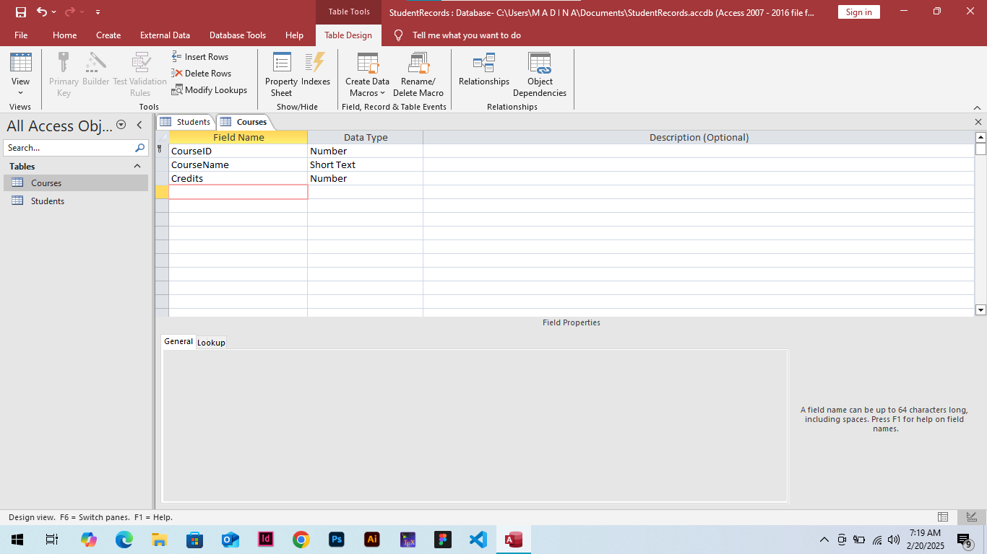
• Create a third table "Enrollments" to establish relationships:
o EnrollmentID (AutoNumber, Primary Key)
o StudentID (Foreign Key from "Students")
o CourseID (Foreign Key from "Courses")
o EnrollmentDate (Date/Time)
steps :
Step 1: Open the Database
Open the "StudentRecords" database.
Step 2: Access Table Design
Click on the "Create" tab in the ribbon and click on "Table Design".
Step 3: Add Fields
In the "Table Design" view, add the following fields:
EnrollmentID
Data Type: AutoNumber
StudentID
Data Type: Number
(Will be set as Foreign Key from "Students" later)
CourseID
Data Type: Number
(Will be set as Foreign Key from "Courses" later)
EnrollmentDate
Data Type: Date/Time
Step 4: Set Primary Key
Select the "EnrollmentID" field and click on the "Primary Key" button in the ribbon.
Step 5: Set Foreign Keys
To set the foreign key make relationship.
Step 6: Save the Table
Click "Save" on the "Quick Access Toolbar" or press Ctrl+S to save the table. Name the table "Enrollments".
The "Enrollments" table is now created with the specified fields and relationships established with the "Students" and "Courses" tables.
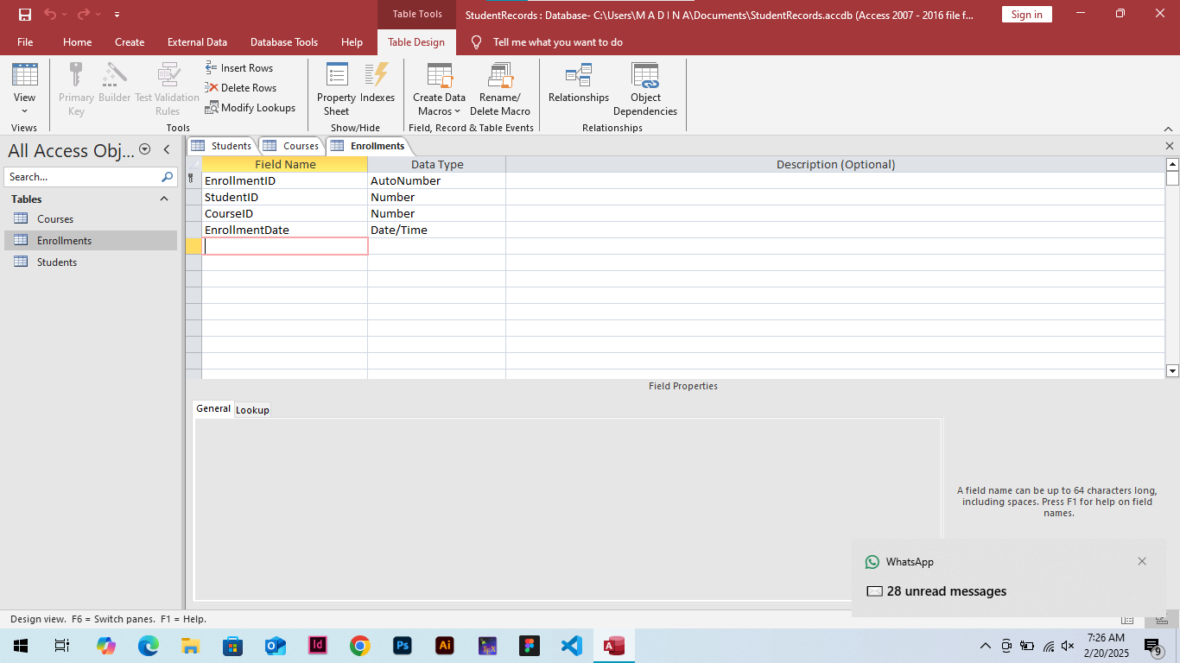

• Use the Relationships tool to link StudentID and CourseID to their respective tables.
Steps
For StudentID
1. Click on the "StudentID" field.
2. Click on the "Relationships" button in the ribbon.
3. In the "Relationships" window, click on "Show Table" and select the "Students" table.
4. Drag the "StudentID" field from the "Students" table to the "StudentID" field in the "Enrollments" table.
5. Click "OK" to confirm the relationship.

For CourseID
1. Click on the "CourseID" field.
2. Click on the "Relationships" button in the ribbon.
3. In the "Relationships" window, click on "Show Table" and select the "Courses" table.
4. Drag the "CourseID" field from the "Courses" table to the "CourseID" field in the "Enrollments" table.
5. Click "OK" to confirm the relationship.

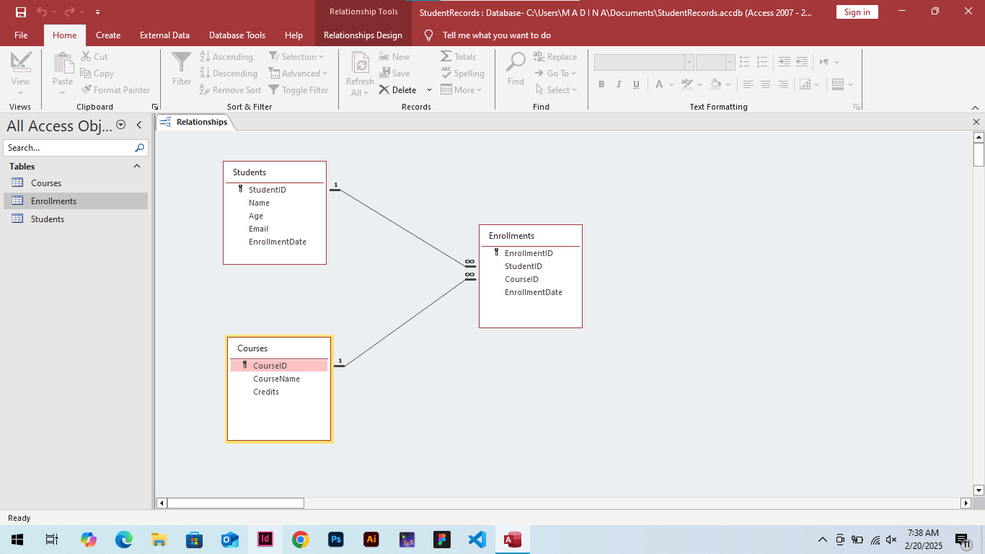
POST LAB TASK
Objective: Explore why MS Access is suitable for library management. Research and answer the following:
• What are the key advantages of using MS Access over Excel for managing books and users?
Answer: following are the advantages of MS Access :
1. Centralized Data Management: MS Access allows for centralized data management, making it easier to manage and update data.
2. Improved Data Integrity: MS Access provides built-in data validation features, ensuring that data is accurate and consistent.
3. Enhanced Security: MS Access provides robust security features, including password protection and user-level access control.
4. Scalability: MS Access databases can grow and adapt to changing needs, making it an excellent choice for large and complex datasets.
5. Multi-User Support: MS Access allows multiple users to access and manage the database simultaneously.
6. Data Relationships: MS Access enables you to establish relationships between different tables, making it easier to manage complex data.
7. Automated Tasks: MS Access allows you to automate tasks using macros, making it easier to perform repetitive tasks.
8. Customizable Forms: MS Access allows you to create customizable forms, making it easier to enter and manage data.
9. Advanced Querying: MS Access provides advanced querying capabilities, making it easier to extract insights from your data.
10. Integration with Other Microsoft Tools: MS Access integrates seamlessly with other Microsoft tools, such as Excel, Word, and Outlook.

• What are the limitations of MS Access, and how could they be addressed?
Answer: following are the Limitations of MS Access and solution to overcome ;
1. Steep Learning Curve: MS Access can be challenging to learn, especially for those without prior experience.
- Solution: Provide training and support for users, and utilize online resources and tutorials.
2. Limited Web-Based Access: MS Access is primarily designed for local use, limiting web-based access.
- Solution: Use MS Access Online or third-party solutions, such as remote desktop connections or web-based interfaces.

3. Data Size Limitations: MS Access has limitations on data size, which can impact performance.
- Solution: Regularly back up and archive data to maintain performance, and consider upgrading to a more robust database management system.
4. Limited Advanced Analytics: MS Access has limited advanced analytics capabilities compared to other database management systems.
- Solution: Integrate MS Access with other Microsoft tools, such as Power BI, to enhance analytics capabilities.
5. Security Risks: MS Access databases can be vulnerable to security risks if not properly secured.
- Solution: Implement robust security measures, such as password protection, encryption, and access controls.
6. Compatibility Issues: MS Access may have compatibility issues with other software applications or operating systems.
- Solution: Ensure compatibility by checking system requirements and using compatible software applications.
7. Limited Collaboration Features: MS Access has limited collaboration features compared to other database management systems.
- Solution: Use third-party solutions or integrate MS Access with other Microsoft tools, such as SharePoint, to enhance collaboration features.

• Identify two real-world organizations that use MS Access for database management.
Answer :
1. Harvard University Library: Harvard University Library uses MS Access to manage its library collections and circulation data. The library's database, which is built using MS Access, tracks book circulation, patron information, and collection development.

2. National Library of Australia: The National Library of Australia uses MS Access to manage its library databases and collections. The library's MS Access database stores information on books, journals, and other materials, and provides staff with a centralized platform for managing library operations.

Identifying Key Objects in MS Access
Objective: Understand the essential components of MS Access.
MS Access vs. Excel: When to Use Each?
Use MS Access:
1. Complex database management: MS Access is ideal for managing large, complex datasets with multiple tables and relationships.
2. Multi-user environments: MS Access supports simultaneous access by multiple users, making it suitable for collaborative projects.
3. Data validation and security: MS Access provides robust data validation and security features, ensuring data accuracy and integrity.
4. Customizable forms and reports: MS Access allows for creating customized forms and reports, making it easier to interact with and analyze data.

Use Excel:
1. Simple data analysis: Excel is perfect for quick data analysis, chart creation, and ad-hoc reporting.
2. Small datasets: Excel is suitable for managing small to medium-sized datasets.
3. Ad-hoc calculations: Excel's formulas and functions make it ideal for performing ad-hoc calculations and data manipulation.
4. Data visualization: Excel's charting and visualization tools make it easy to create interactive and dynamic dashboards.
Objective: Compare MS Access and Excel for database management.
• Create a comparison table highlighting at least five key differences between MS Access and Excel.

Feature | MS Access | Excel
Data Validation | Built-in data validation features | Limited data validation
Data Management | Relational database management system | Spreadsheet program
Data structure | Tables, forms, reports, and queries | Worksheets, charts, and pivot tables
Data Scalability | Suitable for large, complex datasets | Suitable for small to medium-sized datasets
Multi-User Support | Supports simultaneous access by multiple users | Supports simultaneous access by multiple users

• Explain a scenario where Excel would still be useful in the library.
Answer :
Scenario: Collection Analysis and Reporting
A librarian wants to analyze the library's collection to identify trends, gaps, and areas for improvement. They need to:
1. Track circulation statistics for different book genres.
2. Analyze the age and condition of books in the collection.
3. Identify areas where the collection needs to be updated or expanded.

Why Excel is useful in this scenario:
1. Data analysis: Excel's formulas and functions make it easy to analyze circulation statistics, calculate averages, and identify trends.
2. Data visualization: Excel's charting and visualization tools enable the librarian to create interactive and dynamic dashboards to present findings to stakeholders.
3. Ad-hoc calculations: Excel allows the librarian to perform quick calculations and data manipulation, making it easy to explore different scenarios and "what-if" analyses.
How Excel can be used in conjunction with MS Access:
1. Data export: The librarian can export data from MS Access into Excel for analysis and reporting.
2. Data import: The librarian can import data from Excel into MS Access to update the library's database.
By using Excel in conjunction with MS Access, the librarian can leverage the strengths of both tools to gain insights into the library's collection and make informed decisions.

Creating the Database
Objective: Set up a library database.
• Open MS Access and create a new database named "Library_Management".
STEPS
Step 1: Launch MS Access
Open MS Access on your computer.
Step 2: Click on "Blank Database"
In the start-up screen, click on "Blank Database".
Step 3: Enter Database Name
In the "File Name" field, enter "Library_Management".
Step 4: Choose Database File Format
Select "Access Database (*.accdb)" as the file format.
Step 5: Click "Create"
Click the "Create" button to create the new database.
Step 6: Set Database Password (Optional)
If prompted, set a password for the database or click "Cancel" to skip.
Step 7: Database Created
The "Library_Management" database is now created and open in MS Access.
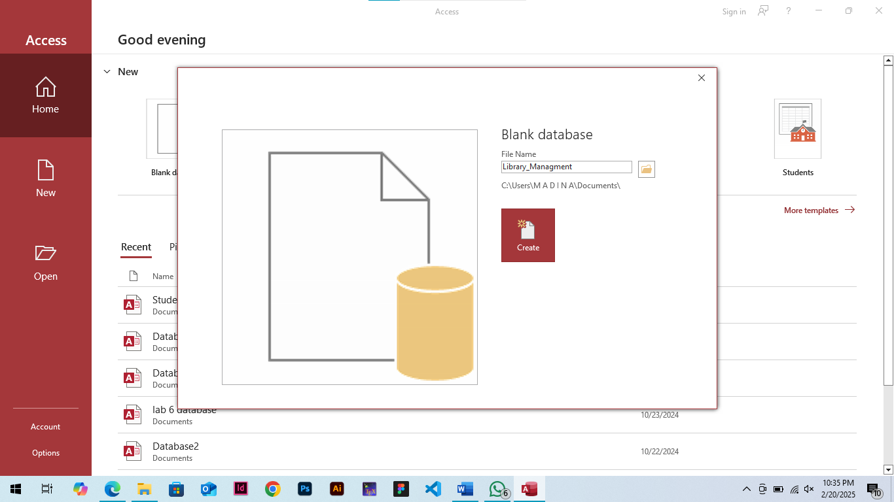
Define three tables:
o Books (BookID, Title, Author, Genre, YearPublished, AvailabilityStatus)
STEPS
Step 1: Open MS Access
Open MS Access on your computer.
Step 2: Select the Database
Select the "Library_Management" database.
Step 3: Click on "Create" Tab
In the ribbon, click on the "Create" tab.
Step 4: Click on "Table Design"
In the "Create" tab, click on the "Table Design" button.
Step 5: Enter Table Name
In the "Table Name" field, enter "Books".
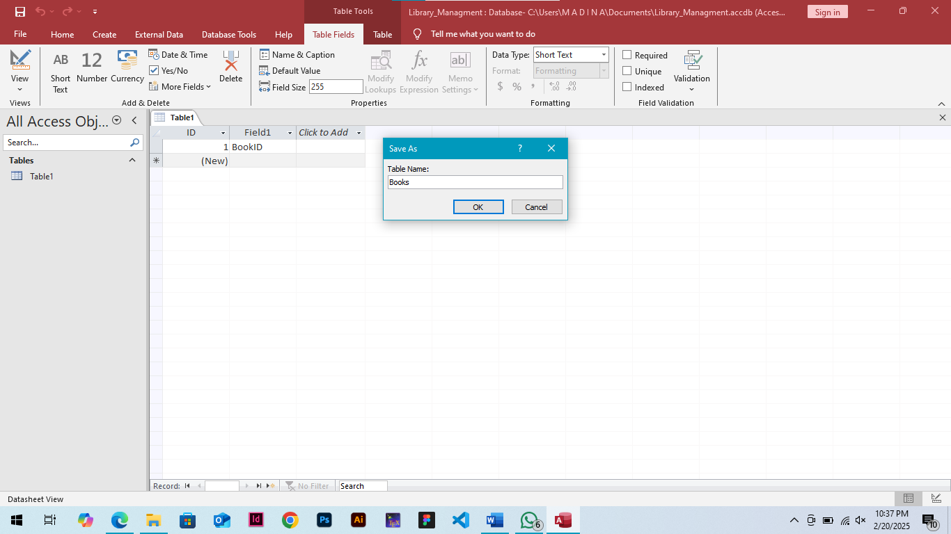
Step 6: Define Fields
In the "Field Name" column, enter the following field names and their corresponding data types.
Step 7: Set Field Properties
Set the field properties for each field.
Step 8: Save Table
Click "Save" to save the "Books" table.
The "Books" table is now created in the "Library_Management" database.
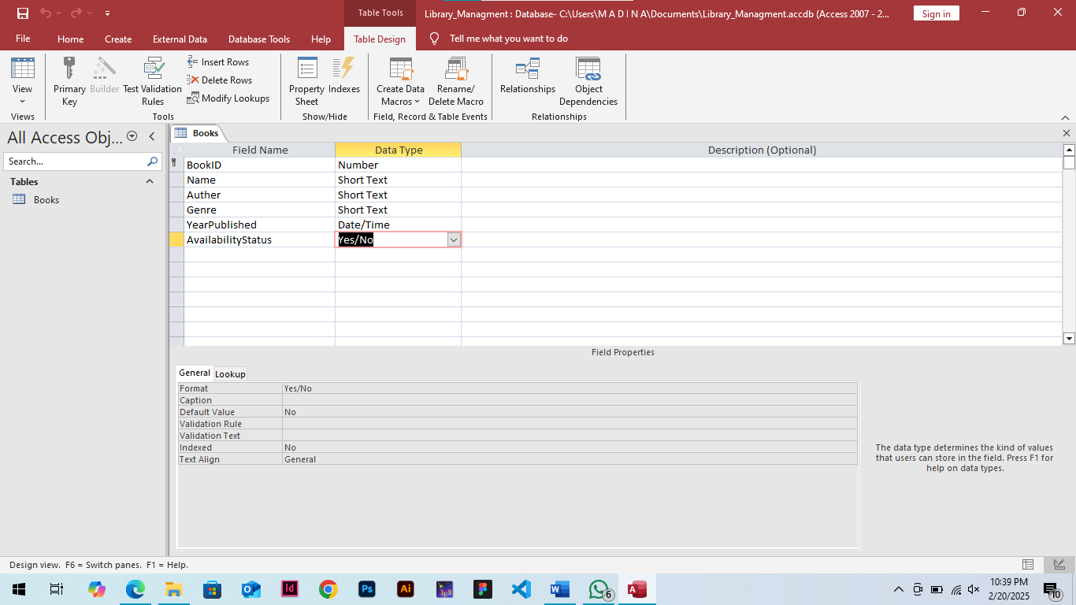

o Students (StudentID, Name, Department, ContactNumber)
STEPS
Step 1: Open MS Access
Open MS Access on your computer.
Step 2: Select the Database
Select the "Library_Management" database.
Step 3: Click on "Create" Tab
In the ribbon, click on the "Create" tab.
Step 4: Click on "Table Design"
In the "Create" tab, click on the "Table Design" button.
Step 5: Enter Table Name
In the "Table Name" field, enter "Students".
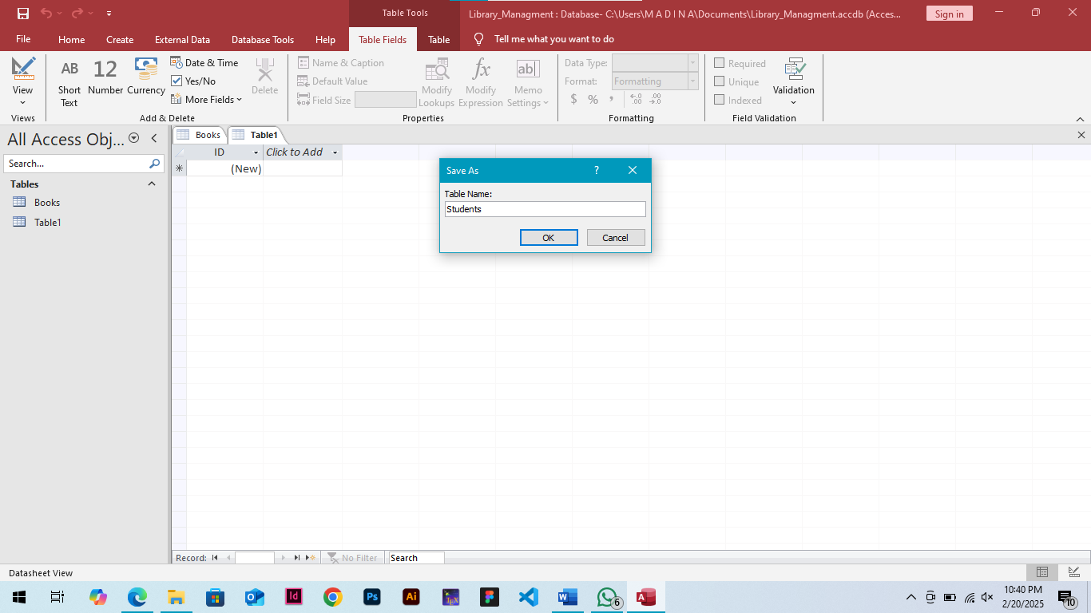
Step 6: Define Fields
In the "Field Name" column, enter the following field names and their corresponding data types.
Step 7: Set Field Properties
Set the field properties for each field.
Step 8: Save Table
Click "Save" to save the "Students" table.
The "Students" table is now created in the "Library_Management" database.

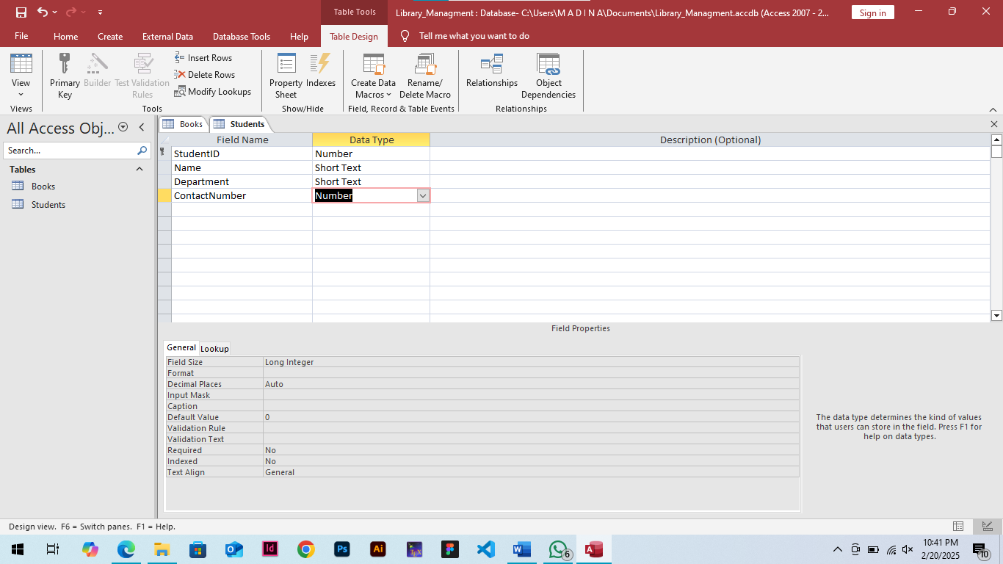

o BorrowedBooks (BorrowID, StudentID, BookID, BorrowDate, DueDate,
ReturnDate)
STEPS
Step 1: Open MS Access
Open MS Access on your computer.
Step 2: Select the Database
Select the "Library_Management" database.
Step 3: Click on "Create" Tab
In the ribbon, click on the "Create" tab.
Step 4: Click on "Table Design"
In the "Create" tab, click on the "Table Design" button.
Step 5: Enter Table Name
In the "Table Name" field, enter "BorrowedBooks".
Step 6: Define Fields
In the "Field Name" column, enter the following field names and their corresponding data types.
Step 7: Set Field Properties
Set the field properties for each field.
Step 8: Save Table
Click "Save" to save the "BorrowedBooks" table.
The "BorrowedBooks" table is now created in the "Library_Management" database.
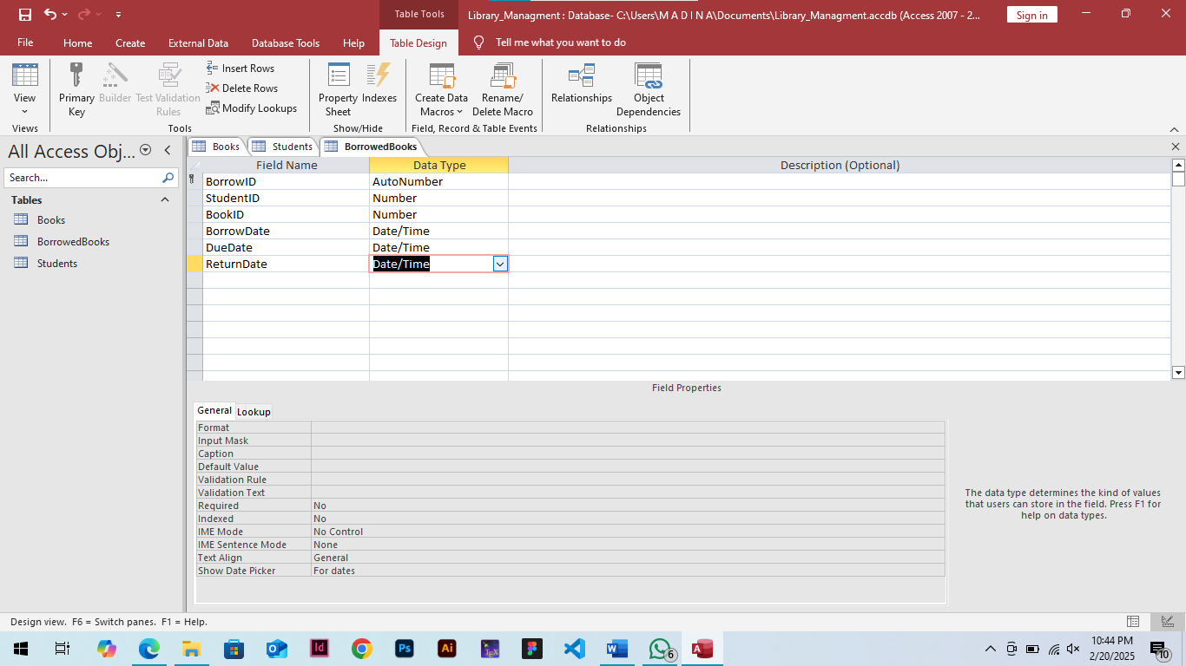

Assigning a Primary Key
Objective: Understand the importance of primary keys.
• Assign a Primary Key to each table and explain its importance.
Steps to Assign a Primary Key
Books Table
1. Open the "Books" table in MS Access.
2. Click on the "BookID" field.
3. Go to the "Design" tab in the ribbon.
4. Click on the "Primary Key" button in the "Tools" group.
5. The "BookID" field will now be designated as the primary key.


:- here key symbol shows that the field is primary key of table.

Students Table
1. Open the "Students" table in MS Access.
2. Click on the "StudentID" field.
3. Go to the "Design" tab in the ribbon.
4. Click on the "Primary Key" button in the "Tools" group.
5. The "StudentID" field will now be designated as the primary key.

:- here key symbol shows that the field is primary key of table.

BorrowedBooks Table
1. Open the "BorrowedBooks" table in MS Access.
2. Click on the "BorrowID" field.
3. Go to the "Design" tab in the ribbon.
4. Click on the "Primary Key" button in the "Tools" group.
5. The "BorrowID" field will now be designated as the primary key.

:- here key symbol shows that the field is primary key of table.
Importance of Primary Key
A primary key is a unique identifier for each record in a table. It serves several purposes:
1. Uniqueness: Ensures that each record in the table has a unique identifier.
2. Data Integrity: Prevents duplicate records from being entered into the table.
3. Relationships: Enables relationships to be established between tables.
4. Querying: Allows for efficient querying and retrieval of data.
5. Indexing: Automatically creates an index on the primary key field, improving query performance.
By assigning a primary key to each table, you ensure data integrity, uniqueness, and efficient querying, making it easier to manage and analyze your library management system.
Discuss the potential issues of not assigning a primary key in database management.
Answer:
1. Data Integrity Issues: Duplicate records, data redundancy, and inconsistencies.
2. Slow Query Performance: Without a primary key, queries take longer to execute.
3. Data Loss and Recovery Issues: Difficulty recovering data in case of errors or crashes.
4. Relationship Establishment Issues: Hard to establish relationships between tables.
5. Data Inconsistencies: Inaccurate or inconsistent data due to lack of unique identifiers.
Entering and Modifying Data
Objective: Learn how to add, edit, and delete records in MS Access.
• Add five book records to the "Books" table.
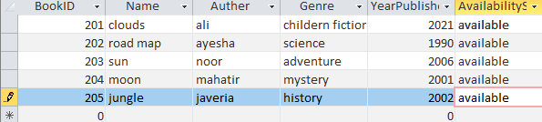

• Update the availability status of a book after borrowing.
Steps to Update Availability Status
Step 1: Open the "Books" Table
1. Open MS Access.
2. Select the "Library_Management" database.
3. In the Navigation Pane, click on the "Books" table.
Step 2: Find the Book Record
1. Click on the "Home" tab in the ribbon.
2. In the "Find" group, click on the "Find" button.
3. Enter the BookID or Title of the book to find the record.
Step 3: Update the Availability Status
1. Once the book record is found, click on the "AvailabilityStatus" field.
2. Change the status from "Available" to "Checked Out".
Step 4: Save Changes
1. Click on the "Save" button in the "Records" group.
2. The updated availability status will be saved to the "Books" table.
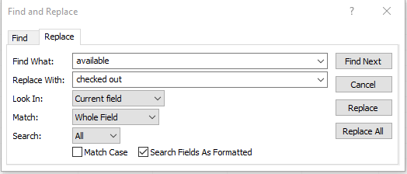
After update the availabilitystatus
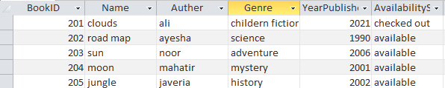

• Delete a book record and explain how it affects related data.
Steps to Delete a Book Record
1. Open MS Access and select the "Library_Management" database.
2. In the Navigation Pane, click on the "Books" table.
3. Click on the "Home" tab in the ribbon.
4. In the "Find" group, click on the "Find" button.
5. Enter the BookID or Title of the book to find the record.
6. Once the book record is found, click on the record selector (the box to the left of the record).
7. Press the "Delete" key or right-click and select "Delete Record".
8. Confirm the deletion by clicking "Yes" in the dialog box.
Before delete of record
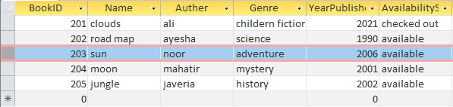
After delete of record
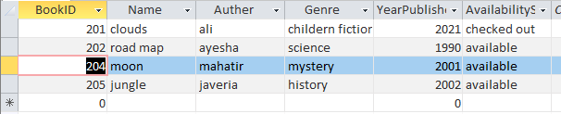
How Deleting a Book Record Affects Related Data
Deleting a book record can affect related data in the following ways:
1. BorrowedBooks Table: If the deleted book has any related records in the "BorrowedBooks" table (e.g., borrowing history), those records will also be deleted or become orphaned.
2. Student Records: If a student has borrowed the deleted book, their borrowing history will be affected.
3. Book Statistics: Deleting a book record can affect book statistics, such as the total number of books in the library or the number of books borrowed.
To avoid data inconsistencies, it's essential to consider the relationships between tables before deleting a book record. You may want to:
1. Backup your database before making any changes.
2. Check for related records in other tables.
3. Update or delete related records accordingly.
4. Verify data consistency after deleting the book record.

Setting Up Relationships
Objective: Establish relationships between tables using Foreign Keys.
• Create a relationship between:
o "Students" and "BorrowedBooks" (linked by StudentID)
Steps to Create a Relationship
Step 1: Open the Relationships Window
1. Open MS Access and select the "Library_Management" database.
2. Click on the "Database Tools" tab in the ribbon.
3. Click on the "Relationships" button in the "Relationships" group.
Step 2: Add Tables to the Relationships Window
1. In the Relationships window, click on the "Show Table" button.
2. Select the "Students" table and click "Add".
3. Select the "BorrowedBooks" table and click "Add".
Step 3: Create the Relationship
1. Drag the "StudentID" field from the "Students" table to the "StudentID" field in the "BorrowedBooks" table.
2. Release the mouse button to create the relationship.
Step 4: Edit the Relationship
1. Double-click on the relationship line between the two tables.
2. In the "Edit Relationships" dialog box, select the "Cascade Update Related Fields" option.
3. Click "OK" to save the changes.
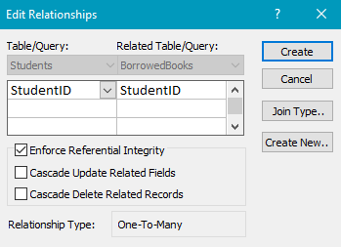

o "Books" and "BorrowedBooks" (linked by BookID)
Steps to Create a Relationship
Step 1: Open the Relationships Window
1. Open MS Access and select the "Library_Management" database.
2. Click on the "Database Tools" tab in the ribbon.
3. Click on the "Relationships" button in the "Relationships" group.
Step 2: Add Tables to the Relationships Window
1. In the Relationships window, click on the "Show Table" button.
2. Select the "Books" table and click "Add".
3. Select the "BorrowedBooks" table and click "Add".
Step 3: Create the Relationship
1. Drag the "BookID" field from the "Books" table to the "BookID" field in the "BorrowedBooks" table.
2. Release the mouse button to create the relationship.
Step 4: Edit the Relationship
1. Double-click on the relationship line between the two tables.
2. In the "Edit Relationships" dialog box, select the "Cascade Update Related Fields" option.
3. Click "OK" to save the changes.
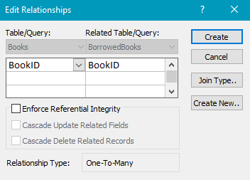

• Use the Relationships tool to visualize these links.
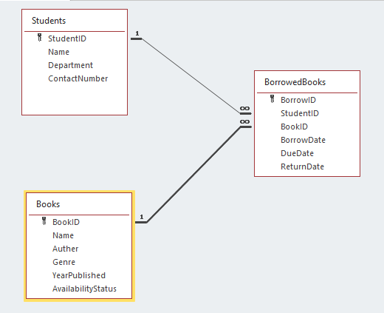

Lifelong Learning Component
Suggest an improvement to the Library Management System, such as automating fine calculations for late returns or adding a librarian login interface.
Answer :
Automating Fine Calculations
1. Automate fine calculations: Create a formula to automatically calculate fines for late returns based on the due date and return date.
2. Send reminders: Set up an automated email or notification system to remind patrons of upcoming due dates and overdue books.
Librarian Login Interface
1. Create a librarian login: Design a secure login interface for librarians to access the system, allowing them to manage book inventory, track borrowing history, and update patron information.
2. Role-based access control: Implement role-based access control to restrict access to sensitive features and data, ensuring that only authorized librarians can perform specific tasks.
Additional Features
1. Book recommendation system: Develop a recommendation system that suggests books to patrons based on their borrowing history and reading preferences.
2. Online catalog search: Create an online catalog search feature that allows patrons to search for books by title, author, or keyword.
3. Self-service kiosk: Design a self-service kiosk that enables patrons to check out and return books, pay fines, and update their account information.
4. Analytics and reporting: Develop an analytics and reporting feature that provides insights into borrowing trends, book popularity, and library usage.
Technical Improvements
1. Cloud-based infrastructure: Migrate the system to a cloud-based infrastructure to improve scalability, reliability, and accessibility.
2. Mobile optimization: Optimize the system for mobile devices, enabling patrons to access the catalog, check out books, and manage their account on-the-go.
3. Security enhancements: Implement robust security measures, such as encryption, firewalls, and access controls, to protect patron data and prevent unauthorized access.

